Moving out Sale
TV & TV Table | $30 | Washing Machine | $130
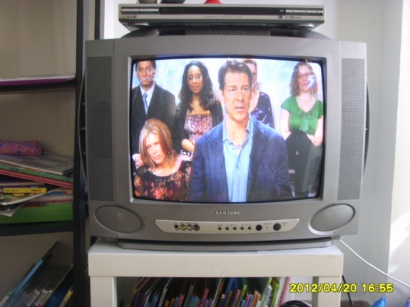 |  | 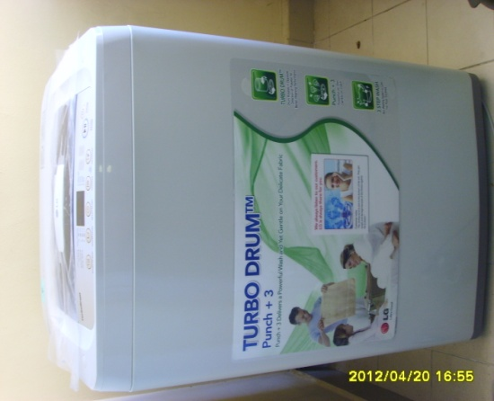
Good Working |  | Only 9 months use
Chair X 3 | $15 | Portable Air Con | $190
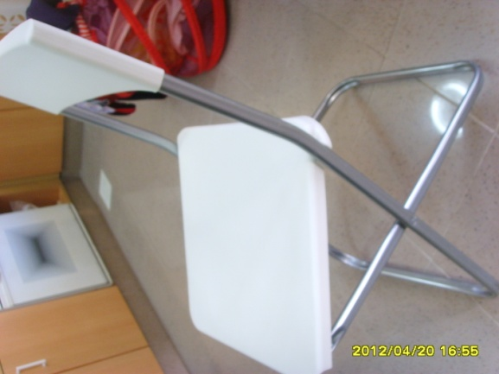 |  | 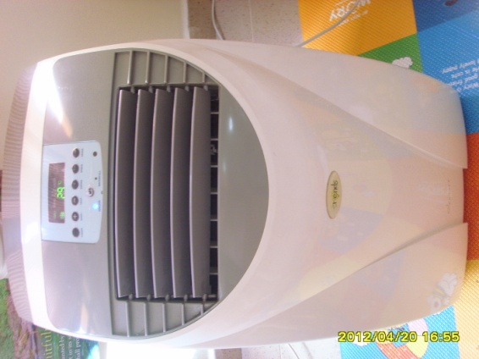
IKEA |  | 16,000BTU & Ionize function

- Call or SMS to 9812-2635 by the end of April

98122635 | 98122635 | 98122635 | 98122635 | 98122635 | 98122635 | 98122635 | 98122635 | 98122635 | 98122635

