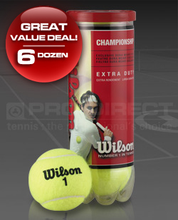
£6.99 in single tubes!
The Wilson Championship Tennis Balls have been designed to be longer lasting and more consistent by using Duraweave Felt specifically engineered for hard court surfaces. But at the same time are perfectly suited to all surfaces.
Wilson have taken their knowledge of making superior tennis balls and put that know-how into making this competitive line of tennis balls.
These Wilson Championship Tennis Balls are for players that demand the best and ideal for tennis coaches looking for value and durability.

